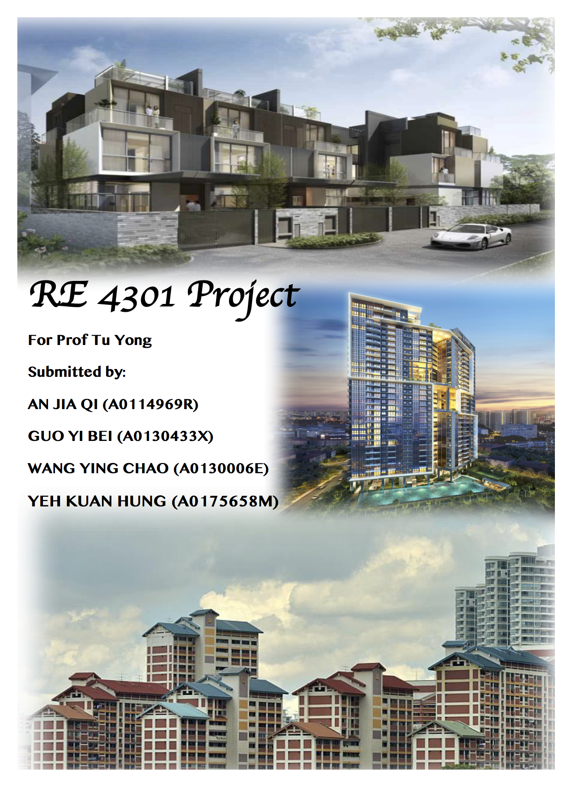

Table of Contents

Framework 3

1.1 Housing Options 4

1.1.1 Singapore 4

Public Sector 4

Private 4

Hybrid 5

1.1.2 Hong Kong 5

Public Sector 5

Private Sector 5

1.2 Housing Ladder 5

1.2.1 Singapore 5

HDB flat 6

DBSS (Design,Build,and Sell Scheme) 6

EC (Executive Condominium) 6

Landed Housing 7

1.2.2 Hong Kong 7

Private Housing 7

Public Rental Housing(PRH) 7

Subsidised Sale Flat 8

1.3 Housing difficulties and solution 8

1.3.1 Singapore 8

1.3.2 Hong Kong 11

2. Millennial Generation’s Choice 12

2.1 Pension problem 12

2.2 Rent instead of Buy 14

2.3 Migrate to homogenous coastal cities along the Strait of Malacca 15

Conclusion 16

Bibliography 17

Appendix 21

Appendix A 21

Appendix B 21

Appendix C 23

Individual Contribution 24

# Framework

For 1.1-1.4, we questioned why two similar high-density cities, Singapore and Hong Kong, showed different stories after the 2008 Lehman Brother’s crisis? Before 2009, Housing price index between the two countries showed similar fluctuation, yet after 2009, Hong Kong had higher price to income ratio (38.61) than Singapore (22.18) (NUMBEO, 2017). We identify the reason as different homeownership ideology, leading to different homeownership rates (51% vs 91%) and different social rental housing provision (30% vs 4%). We hence explored differing housing policies, options and ladders and how the government intervenes when its people face housing difficulty.

For 2.1 Millennial Generation’s Choice, we positioned ourselves as Millennials born between 1980 to 1987 and use the framework below.

|  |  |  |
| --- | --- | --- |
| **Framework to analyse**  **Housing decision of Millennials**  **(born between 1980-1997)** | | |
| **Trends HDB Face**  **HDB’s CEO: (Cheong, 2016)** | **Millennial Generation’s Reaction** | **Our Proposed Solution** |
| 1.Growing population | 1.Pension problem | -Change our mindset to embrace change |
| 2.Ageing population |
| 3.Aspiration for better quality environment | 2.Rent instead of buy  3.Migrate to homogenous coastal cities along the Strait of Malacca | -Suggest private developers and HDB to selectively adopt rental policies from countries like Switzerland and Germany  -Job creation to retain talent  -Potential of affordable home-ownership in heart of the city |
| 4.Develop and manage infrastructure (i.e. Smart City, Greater Southern Waterfront) |
| 5.Lower energy use to address climate change | NA | NA |

# 1.1 Housing Options

Both real estate markets can be divided up, labelled, categorized, and sliced into different forms of housing types. In this section, we are going to introduce each housing options and suitability when people making housing decisions.

## 1.1.1 Singapore

### Public Sector

Singapore’s public housing has housed more than 80% resident population, with about 90% of them owning their home. Today, more than 1 million flats have been completed in 23 towns and 3 estates across the island. There are many types of housing under public housing category, which will be covered in this section.

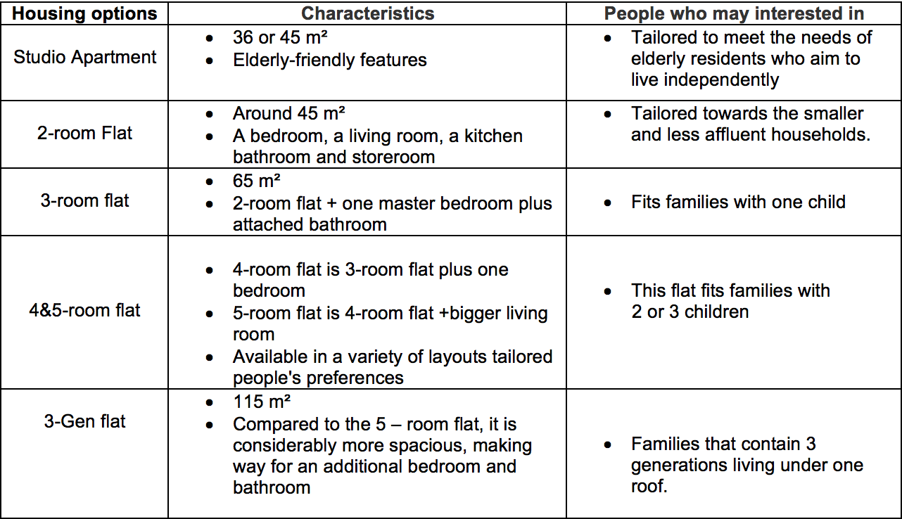

### Private

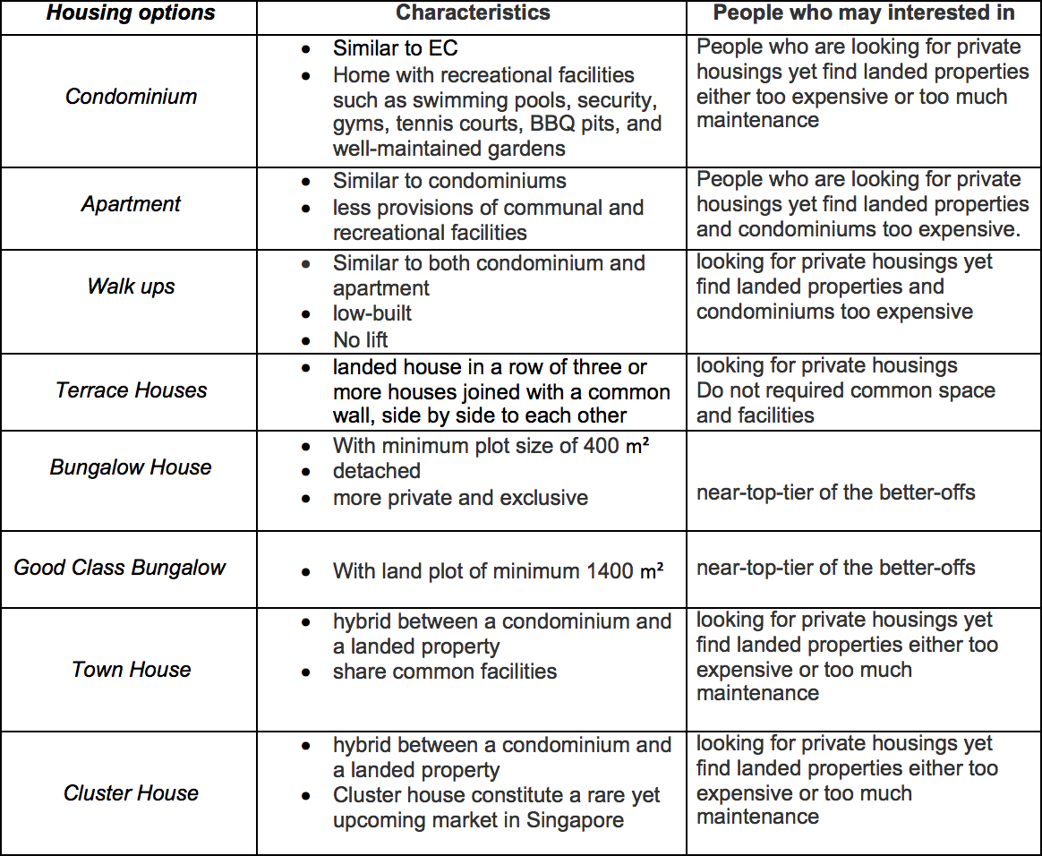

### 

### Hybrid

The Executive Condominium is a type of property starts off as a public housing unit, then phases into private housing after 5 years of ownership. Tailored to young professionals who can afford more than an HDB flat but find private property still a little out of reach, the executive condominium share most of the design and facilities of a private condominium.

## 1.1.2 Hong Kong

According to the Hong Kong Housing Authority, 44.8% of population live in public permanent housing and 54.6% live in private permanent housing. Among the public sector, 29.1% live in rental housing and 15.7% live in subsidised sale flat.

### Public Sector

Public permanent housing accounts for 45.6% of housing types in Hong Kong, sized differently from one person to six persons and more.

### Private Sector

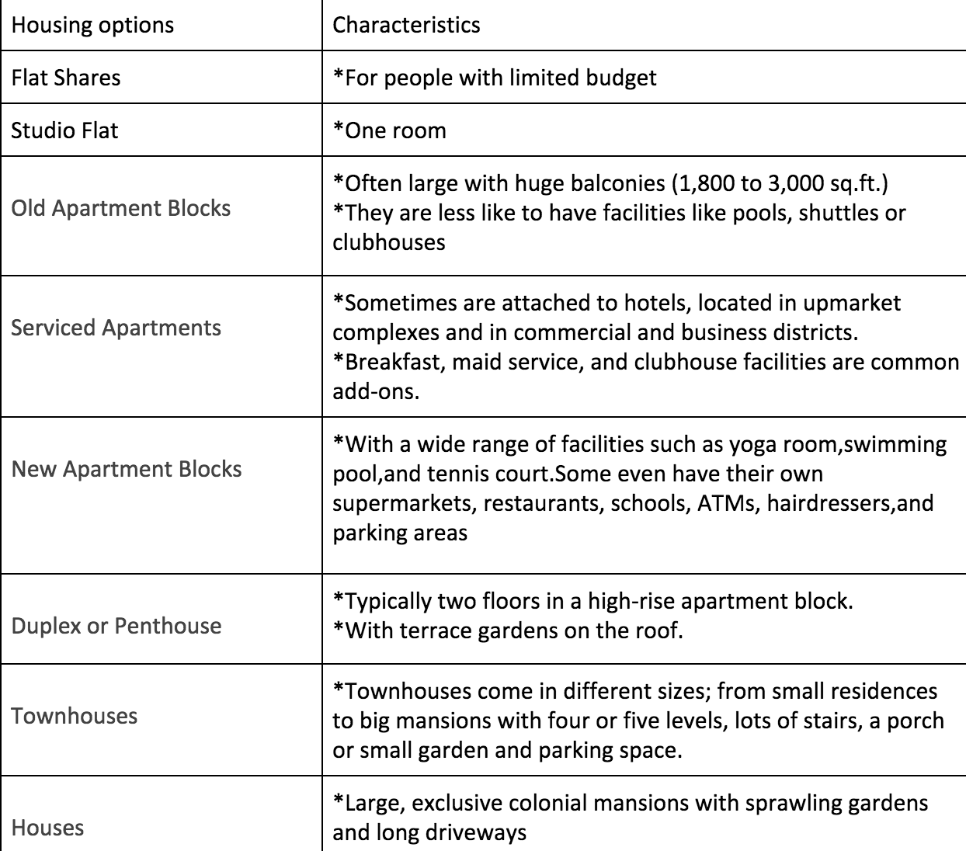

# 1.2 Housing Ladder

## 1.2.1 Singapore

The housing market is highly segmented with regulations on eligibility of households. Only citizen households are eligible for HDB rental and direct purchases, with monthly gross household income caps at S$1,500 for rental and S$12,000 for direct purchase, respectively.

The resale HDB sector is open to citizens and permanent residents (PR) and the private housing sector caters to higher income Singapore citizens, PR, expats, and foreign investors. The Singapore housing ladder is buttressed by synergy of price difference and eligibility for each scheme.

### HDB flat

In the new flat market, the price could be different depending on the status of construction when you buy. HDB flat can be divided into build-to-order (BTO), sale of balance flat (SBF), and re-offer of balance flat (ROF). BTO offers you a more flexible timing and location to buy a new HDB flat even though the construction will only be called when the applicants to the number of apartments in a specific contract reaches a certain ratio. SBF flat is new HDB flat which is near complete construction. ROF sales launches pool together all unsold flats from the previous SBF exercise.

Let us now look at prices. If we take the region of Bukit Batok as an example, the price for BTO starts from $87,000 for 2-room flexi, from $171,000 for 3-room flat, and from $265,000 for 4-room flat while that is $83,000, $165,000, and $246,000 correspondingly for the SBF price. In the resale market, if we take Bukit Batok again as an example, the starting price is $272,000 for a 3-room flat and $400,000 for a 4-room flat. Overall, for the 3-room HDB flat, the average housing price is $310,000, down payment is $31,000, and monthly payment required is $1,535.

HDB could actually cover most of the population if we compare the monthly mortgage with household income and expenditure. According to Statistics Singapore 2016, the average size of a household is 3.2 and only 7.5% of the population with monthly household income less than $2,000. Besides, the starting salary for fresh graduate ranges from $3,500 to $4,000. Minusing the minimum household expenditure, which is from $200 to $600, HDB is considered affordable.

For the normal applicant of 2-room flexi flat(up to 99 years lease), the income ceiling is $6,000. Nevertheless, if you are the first-timer applicant, there will be up to $40,000 grant depending on your monthly salary. Even though there is a income ceiling of $5,000, it could still include the freshman graduate salary and 23% of the households. With the scheme, people are able to buy a 2-room flexi or larger HDB flat. In addition, priority to buy is often given to first-timer applicant. However, if you are a 35 years old or older first-timer applicant, the income ceiling will drop a half to $2,500. For first-timer married couple,the parenthood scheme can help you get your HDB flat more easier. Besides, if you are an applicable senior,senior priority scheme, and silver housing bonus could help right-size your current house to HDB flat where may be near your children’s dwellings.

### DBSS (Design,Build,and Sell Scheme)

DBSS flat, which is offered by developers, has similar eligibility conditions as those of a new HDB flat. Maximum monthly household income must not exceed $12,000, or $18,000 if applying with your extended family. First-timer applicant can also apply this type of housing.

### EC (Executive Condominium)

From their sixth to 10th years, ECs are sold like regular resale flats. But from the 11th year, ECs go “fully private”. Your household income must not exceed the $14,000 income ceiling to buy. If you buy an EC, you need to use a bank loan. However, for EC, the average housing price is $910,000, down payment is $182,000, and the monthly payment is $3337, which makes it a larger liability compared to HDB flat.

### Landed Housing

Apart from the higher monthly price and down payment, buyers sometimes have to afford an extra cost from stamp duty and legal cost.

|  |  |  |
| --- | --- | --- |
|  | Average housing price | Monthly payment |
| Terrace house | $2,400,000 | $7,334 |
| Semi attached house | $4,100,000 | $15,134 |
| Bungalow | $10,600,000 | $38,867 |

## 

## 1.2.2 Hong Kong

According to the Transport and Housing Bureau, average housing price for houses less than 40 square meter has reached HK$145,378 in Hong Kong, HK$119,838 in KowLoon, and HK$115,813 in New Territories in 2017. Yet survey done by jobsDB reveal that fresh graduates are getting an average monthly salary of HK$14,685 in their first job in 2017. Besides,people with monthly household income less than HK$20,000 account for 56% in Hong Kong. Mentally, the stunning price can undermine people’s willingness to buy real-estate and confidence in homeownership. In response to the problem, Hong Kong government proposes three policies, (1) Public Rental Housing, (2) Home Ownership Scheme, and (3) Sandwich Class Housing Scheme. The form of a housing ladder is able to meet the housing needs of different social strata, which will gain stronger public support.

### Private Housing

According to the Census and Statistics Departments,the median rent-to-income ratio in private housing is 25.7 while that in public housing is only 10.6 . Here are the monthly rental rates for different types of housing:

Flat Shares :HK$3,500 ~ HK$15,000/month

Studio Flat:HK$8,000/month above

Old Apartment:HK$25,000/month above

Serviced Apartment:HK$10,000-50,000/month

New Apartment Blocks:HK$50,000/month above

Duplex or Penthouse:HK$60,000/month above

Townhouses:HK$100,000

Houses:HK$150,000 above

### Public Rental Housing(PRH)

In Hong Kong, public rental housing (PRH) accommodates almost 30% of its total population. According to the Hong Kong Housing Authority, there are four schemes to apply for the PRH programme, which are ordinary families scheme, single elderly persons priority schemes, elderly persons priority scheme, and harmonious families priority scheme. In the ordinary families scheme, there are maximum income limit and total net asset limit for the qualification. For household with only one person, the maximum income limit is HK$11,250/month. For household with three people, the maximum income limit is HK$22,390.

If we look at the data of monthly wage for all employees by decile group, we can see that the lowest 10% wage population has HK$9,000/month, 25% wage population has HK$11,600/month, and the median salary is around HK$16,200. That is, the public housing could cover nearly 25% of the working population. Furthermore, household income is closely related to household size. In general, households with one to two persons have less working members and thus usually have lower household income. Based on the statistics from the Census and Statistics Census, Hong Kong, there are 2,548,000 households with average size of 2.8 people in Hong Kong. In 2016, households with less than 24,999 income account for nearly 50%. Households with financial hardships can also apply for 25~50% rent reduction.

In the rest of the three other schemes, they consider the elderly members in the family and tolerate a higher maximum income limit. For example, for non-related elderly households with 2 persons, the maximum limit is HK$20,820 and the total asset limit is HK$666,000. Since most of the elderly households were retirees who do not have employment income, their median household income is usually lower than that of all domestic household in Hong Kong. It is estimated that the average income of the elderly population is HK$ 5,900. Nevertheless,the elderly population is usually said to be asset rich and cash free. The programme provides an another option for them to release their asset and rent a public house. In terms of the rent for public rental housing.it is around HK$54~68/month per square metre. If we consider the average living expense in Hong Kong,which is HK$6865/month, the programme should provide an affordable living for the low income population or fresh graduate. In 2017,there are 147,000 applicants for the programme.

### Subsidised Sale Flat

Home ownership programme(HOS)

This programme encourages PRH tenants to attain homeownership with discount, which includes applicants for private sector or public sector. Under the established HOS methodology, the asset limit is derived from the amount of expenditure required to finance the downpayment and the related transaction costs and decoration expenses for acquiring the reference flat.

Sandwich Class Housing Scheme

This programme aims at helping middle income households who are not applicable for HOS or PRH programme to own a private sector.

# 1.3 Housing difficulties and solution

Evaluation of policies according to its type is done via a trend-over-time analysis.

## 1.3.1 Singapore

*“When there are troubles to go through, we will find a way to start anew.” - Minister of State Dr Koh Poh Koon, when discussing Tenants’ Priority Schemes (Koh, 2016)*

IN 1947, the **Rent Control Act (regulation)** (pegged at 1939 rents) targeted low to middle skilled Singapore residents, many of whom were new immigrants. It was phased out in 1988 when (1) **HDB’s HDB’s “Home Ownership for the People” Scheme (HOS)** worked and (2) Government shifted focus to conserve historical areas with private sector participation.

In 1958 there was traces of HDB’s **Public Rental Scheme (PRS) (provision)** via its predecessor Singapore Improvement Trust during the British colonial days, with the evidence of Dakota Crescent’s 648 2-3 room units housing mostly elderly residents and low-income families under PRS. (Koh, 2017).

In 1964, HDB’s HOS (provision) targeted to low-income households not exceeding S$800 per month. Reason for this policy was to (1) Promote deliberate homeownership for Singapore residents in a period of social and political instability (2) Take care of welfare of the people. HDB did so by offering housing units for 99-year leasehold with monthly mortgage payments on loans priced lowering than that of rents. Buyers could get loans at 6.25 per cent interest, repayable over five to 20 years.

However, demand was slow initially because it was beyond means of most breadwinners. It was only after the Government from 1968 allowed **(regulations)** such as use of CPF savings as initial down payment and subsequent instalments, that led to over 406,600 CPF members withdrawing $2,323.3 million to buy flats in 1988. (Lee,1990) To ramp up the supply and lower the cost of land acquisition, the Government also introduced the Land Acquisition Act in 1966. Homeownership rate rose to 29% in 1970 and 89% as at 2013 (Phang, 2013).

Here is a profile of how residents reacted. Mr How, who after moving through several kampungs and rented homes, could buy a five-room flat at Ghim Moh in 1978. He said, "I was so proud of my first house. There were some defects - doors were wobbly and couldn't close properly - but we did renovations. It was a good location." It cost $35,000 and he paid for it out of his CPF. (Lee, 1990)

In 1993, HDB deregulated the resale market targeting mainly low-income **Permanent Residents (PR) (on top of Singaporeans) to own resale flats (regulation)**. Previously those ineligible for PRS could only sublease from existing HDB flat owners, which may erode their savings and make it harder for them to save up for down payment. HDB granted loan financing up to 80% current valuation or declared resale price whoever is lower and allowed withdrawal of CPF saving to meet interest payment on mortgage loans. The transaction volume of resale HDB flats increased from fewer than 800 units in 1979, to 13,000 units in 1987, 60,000 units in 1999, and 31,000 in 2004. Resale transactions as a proportion of total (new and resale) owner-occupied public housing transactions, were three %, 37%, 64% and 68% in 1979, 1987, 1999 and 2004 respectively (HDB Annual Reports).

In 2006, HDB gave **Additional CPF Housing Grant (subsidy)** to low-income first-time buyers to purchase HDB. Nowadays, HDB has grants up to $90,000, via (1) Proximity grant (2) First-timer grant (3) Additional Housing Grant. Note fine print of CPF Grants in Appendix A.

As for **Public Rental Scheme (provision),** it provide low-income families with cap in household earned income to be less than or equal to $1,500 with housing in low-cost units through heavily subsidised rentals. These flats are integrated within HDB BTO flats for social integration and shared use of amenities. Two main schemes PRS, namely the Family Scheme and the Joint Singles Scheme with strict eligibility criteria (table x in Appendix B) and Debate on how the cap in household income should be raised is discussed in Appendix B.

The Public Rental Scheme supply ramped up from 42,000 in 2007 to 53,500 in 2016 and 60,000 in 2017. This reduced waiting time for rental flat from 21 months in 2008 to 4 months in 2016 (Koh, 2016). The wait can be longer for certain racial groups due to the unintended consequence of the Ethnic Integration Policy introduced in 1989. For those in urgent need there is priority allocation. Two schemes come under this umbrella:

**(1) Tenant Priority Scheme (2011) (provision)**

It encourages first-timer renter families to take up home-ownership flats by setting aside 10% of 2 and 3-room flats under sales exercises for them. In 2011, 411 2-room flats were set aside, which was 8.5 times more than the 40 applications in 2011. It was extended to second-timer families in 2016 to raise their allocation quota.

**(2) The Fresh Start Housing Scheme (2016) (provision)**

It helps second-timer renter families to buy a home-ownership flat. Families who qualify can buy a new 2R Flexi flat with a Fresh Start Housing Grant of up to $35,000 and will be given a HDB concessionary loan, if they commit to a 20-year Minimum Occupation Period. (Wong, 2016). Our group is uncertain if the 20-year MOP will scare some families away, however we are heartened to note that National Development Minister Lawrence Wong emphasised they would be “handheld through this journey.”

As number of elderly above 65 years-old is projected to rise from 450,000 in 2015 to 900,000 by 2030 (Cheong, 2015), the government realised the decline in old-age support ratio’s adverse impact on elderly retirees and stepped up in its efforts. Schemes for lower-income elderly include:

**(1) Silver Housing Bonus Scheme in 2013 (subsidy)** (downsize to smaller flat up to 3-room) targeted lower-income elderly 55 and above with at least one Singapore Citizen; gross monthly household income $12,000 or less, providing $20,000 cash bonus.

**(2) Lease-buyback scheme in 2014 (subsidy)** (monetise at least 20 years of HDB’s tail-end lease paid to Retirement Account) targeted lower-income elderly 64 and above and at least one owner is a Singapore Citizen with Gross monthly household income of $12,000 or less AND a flat-type of 4-room or smaller, allowing them to age-in-place.

**(3) 2-room flexi scheme tied with Senior Priority Scheme (provision)** in 2015 (lease between 15 and 45 years for 36 or 45 square meter flats) targeted low-income Singaporean elderly 55 and above by setting aside half of allocated units for seniors that wish to live near their current flat, or married children. Among 70 BTO projects with 2-room Flexi flats are planned for next 5 years from 2015, at least 40% of the 2-room Flexi flats are available to the elderly). Two years later as at March 2017 there are 1,632 bookings (Baharudin, 2017).

|  |  |  |  |  |
| --- | --- | --- | --- | --- |
| Old-age support ratio (Cheong, 2015) | | | | |
| 1970 | 1990 | 2010 | 2020 | 2030 |
| 13.5 | 10.5 | 7.5 | 3.6 | 2.1 |
|  |  |  |  |  |

## 1.3.2 Hong Kong

From the 1970s, the inadequacy and scarcity of housing flats became a serious problem for Hong Kong necessitating government intervention. The ideology of Hong Kong government is to focus on elderly and the poor, thus housing policies tend to support the lower-income group and assist public housing tenants to become private homeowners. Problems it faced included (1) Shortage supply of public and private housing (2) Low housing affordability (3) Young people who find it increasingly difficult to become homeowners and (4) Pension problem for elderly.

The first major policy announced by Hong Kong government in 1953 is **Public Rental Housing (provision).** This policy is aimed to shelter poor families in Hong Kong. Based on a quota-and-points system, PRH was assigned to applicants aged 18–57 years. The starting point was three for applicants aged 19 years, then three points for each year thereafter. Applicants with higher points had priority. By the end of 2013, more than 2.1 million people were arranged in PRH.However, this successful policy still has its limitation as this policy is difficult to monitor those do not meet the criterion any longer after they moved in. In order to solve this problem, home ownership scheme was introduced later.

The **Home Ownership Scheme (subsidy)** introduced in 1977 is insure Eligible tenants to buy an HOS flat with discount between 30%– 40% below the estimated market value. This policy aims to target the Low-income households in PRH and help them become Homeowners So that the government were able to remove financially affordable households in PRH in order to create space for families who cannot afford to be an owner.

Later on in 1988, in order to assist public housing tenants to become private homeowners. **Home Purchase Loan Scheme (subsidy)** was introduced in order to resettle current tenants in PRH who had higher incomes than the PHR waiting-list limit. Applicants can either rent or buy in the same estate. A 45% discount on the open market value would be offered to whom chose to purchase. Also an interest-free loan of HK$800,000 repayable over 13 years or HK$600,000 repayable over 20 years will be provided. However, this scheme seemed to be unattractive to tenants, because the cost of purchase was 3.5 times the rent paid without any improvement in their housing conditions. Although this is the cheapest way of becoming a homeowner, majority of tenants refuse to buy. In order to future boost the portion of home ownership, **Tenants Purchase Scheme (TPS) (subsidy)** is introduced in 1998 which aimed to help tenants in PRH to purchase the flats they rent. The TPS allows buyers to purchase their flats with 30%–45% discounts with no restriction. Till 2006, 150,000 PRH tenants became homeowner under the assist of this scheme. However, due to the great amount of subsidy, housing storage was soon running out of stock.

In order to provide more houses, **the 85,000 Plan (provision)** was introduced to build 85,000 units of public rental and private ownership flats yearly by the government and developers. This plan helped to increase homeownership rate from 52% to 70% in the next decade, and reduce waiting time for Public Rental Housing(PRH) from 3 years to 2 years.

The government also paid close attention to the young and the old. **Home Starter Loan Scheme (1998) (subsidy)** was proposed to Assist first time buyers with low and middle incomes to buy their first properties; **Reverse Mortgage Programme (2011) (subsidy)** was proposed to assist elderly to unlock home equity into constant cash flows.

The last major policy released by Hong Kong government in 2010 was named **“Spicy Measures” (restriction).** A series of restrictions that were jointly taken by the Legislative Council and the Hong Kong Monetary Authority, it aimed to cool down overheated property market. Although Spicy measures had short-term impacts on decreasing transaction volumes, but failed to choke the increasing trend of property price.

# 2. Millennial Generation’s Choice

## 2.1 Pension problem

We believe that with Trends 1 and 2 Millennials will wisen up against the pension problem. We will not duplicate our parent in the ways of financing their home. Instead, we will build CPF savings to have peace of mind in our retirement years. We will save early and enough which can reduce the need to have to continue working in later life. Also, compared to the previous generation, we are more open for financial innovative instruments to unlock the value of our asset if necessary.

Singapore's retirement income system is mainly based on the Central Provident Fund (CPF) which covers all employed Singaporeans and permanent residents. Residents population are allowed to use the saving from CPF ordinary account to pay for down payment as well as housing instalments. Large portion of CPF saving is taken to pay for housing instalments among Singaporeans and it lead to insufficient savings for retirement. United Nations Population Division’s World Population Prospects states that Singapore’ s pace of ageing is set to outstrip that of Japan, which had moved from a proportion of 9% of population aged 65 and above in 1980 to above 20% in 20 years. The adverse impact is exacerbated by increasing rate of aging.

Many people blame the pension system in Singapore, they argued that the pension system in welfare countries are sustainable and sufficient to support the elderly. However, the political ideology in those welfare countries are different from Singapore. The working population in those welfare countries are charged with heavy individual tax which is their source of retirement income for the elderly. In Singapore, the government believe in self-reliance and sustainability, the individual tax is insignificant which will not affect people’s current life standard and consumption.

Moreover, the 2017 Melbourne Mercer Global Pension Index, which looked at 30 countries covering 60 per cent of the world's population, scores pension systems on their adequacy, sustainability, and integrity. Singapore received an overall B rating with index score of 69.4, up 2.4 points from a year ago, versus a global average of 59.9 points. Mercer said no country achieved the elusive "A" grade. Mercer president of health and wealth, said Japan, Austria, Italy and France are examples of developed economies whose pension systems do not represent a sustainable model that will support current and future generations in their old age. In contrast, Singapore ranking No.1 in Asia. (Shown in Appendix C figure 1.0).

Hence, it shows that Singapore pension system is quite comprehensive and sustainable compared to other countries in Asia. The question may be asked is that why there is still pension problem? Basically, there is nothing wrong with the pension system, it is the problem of how people going to use it and if they have forward-looking for their retirement life. The problem is about their habit and source of funding for their property. An individual member’s CPF balances are held in different accounts: the Ordinary Account (OA), the Special Account (SA), the Medisave Account (MA) and the Retirement Account (RA). The RA is automatically created when a CPF member reaches 55 years of age, when accumulated balances in the OA and the SA are transferred into the RA. Balances in a member’s OA may be withdrawn to purchase a home (or to pay a housing loan), insurance, make approved investments and to finance education. There is increasing trend of withdrawing balance from OA to purchase housing (appendix C figure 2.0). Thousands of journals and working papers also emphasis that people use too much money from OA to finance their house. The home is fully paid-up when they are retired with very little left in OA, which lead to less money in RA for their retirement income.

In other to solve this problem, government provide many ways for resident population to release equity from their property. Currently, elderly homeowners who wish to monetise their flats can do so through schemes such as the Lease Buyback Scheme (LBS) and the Silver Housing Bonus. Introduced in 2009, the LBS allows elderly homeowners to sell part of their flat lease back to the Housing Board for retirement income. The latter gives seniors a cash grant if they downsize their flat and top up their Central Provident Fund retirement account with the sale proceeds.

However, most of the previous generation would like age in place, continue to live at the same place and they are reluctant to take consideration about financial engineering to monetise their house for better living standard due to conservative and do not want to sell part of their lease. (Ong, 2016) Many prefer to bequeath their flat to the next generation instead. Furthermore, the failed Reverse Mortgages scheme introduced in 1997 for private housing homeowners also illustrated their conservative mind-set.

As Millennials with broad aware of the economic and demographic challenges we face. With low interest rates, rising healthcare costs and potentially less state support for retired people in the future, we will not duplicate our parents’ path of sacrificing retirement funds for housing. We will take the advantage of technology, balance our ways of saving and investing to consider different sources of funding. We may choose to rent instead of buy if we cannot afford a house. After learning from previous generation’s experience, we are more realistic and creative in the ways of living. Hence, we suggest changing our mindset to embrace change.

## 

## 

## 2.2 Rent instead of Buy

*“My primary occupation was to give every citizen a stake in this country and its future. I wanted a home-owning society.” - M.M Lee Kuan Yew (Koh, 2016)*

How relevant is the above statement, today? We believe that with Trends 3 the proportion of Singapore’s Millennial Generation who prefer renting instead of becoming a household will increase over the next decade. There had been a significant increase in the percentage of renters rather than homeowners (Hargreaves, 2002).

Two countries did well under the rental phenomenon:

(1) In Switzerland, despite the fact that the homeownership rate is one of the lowest in the world at 33 percent, the country is one of the richest in the world with a very high standard of living. This suggests that homeownership may not essential to insure people’s quality of life. (Bourassa et al, 2010).

(2) In Germany, studies and demographics show that the rental sector provides younger households with an option of accommodation where they can save capital in their *‘Bauspar’* savings account and also save 20% personal capital down payment required for home-ownership (Fitzsimons, 2014).

We believe reasons for Millennials preferring to rent instead of buy include (1) Job Flexibility, (2) Criterion unconformity and (3) Change in Consumption.

Job flexibility is a key factor which affect the Millennial’s preference to rent instead of buy. Knight and Eakin (1997) identify changes in the labour market and societal changes. They contend that corporate downsizing and global competition has resulted in much shorter employment contracts and reduced worker job security. Green and Hendershott (1999) discover a positive correlation between high rates of unemployment and high rates of home ownership, suggesting owners are less willing to move to new jobs than renters. Nowadays, shorter hiring period is increasingly common, which cause people move around much more frequently than in the past. We note that the sector of population most inclined to rent falls within the 20-34 age group, as they change address most within a year.

Criterion unconformity is another problem for young generation, Singapore public housing remains to be the only affordable housing option. Private housing is beyond their affordability. Even though the financial standard is met, one cannot purchase a HDB flat if he is not married and under 35 years old. According to [The Straits Times](http://www.straitstimes.com/singapore/more-young-people-in-singapore-staying-single), the percentage of singles in the 25-29 age group has now hit 70%, this is due to them being more educated and career-driven, facing work-life imbalance and from financial consideration. Hence, Millennials, unlike their parents who usually get married before 30, are delaying marriage and parenthood, which directly delays their eligibility for public housing. If they want to announce their independence by staying away from parents, rental is the only way here.

Change in consumption patterns affect homeownership preference too. According to DIVNOMICS (2015) the millennial generation is used to instant gratification. Instead of saving up for HDB down payment for years, there is increasing tendency for millennials to rent near their workplace.

This is probably because they value time as a currency more, and also because they want more disposable income to improve their quality of life. Also, Millennials are exposed to a lot more different home decor options than their parents (industrial chic style, minimalistic style, modern eclectic style etc.) More Millennials are willing to try out different home decor options before settling for one permanent home later in the future.

Moreover, research done by Anna V. Haotanto showed that about one in five young couples is living in rented flats. According to this survey, this is because image-conscious Millennials prefer privacy, convenience and glamour of living in private properties. Comparing to private properties, HDB is not favored by some Millennials due to the lack of privacy and facilities, poor Architectural design and parking problem. This point of view is also supported by a large portion of critical comments about HDB on Quora (A website). Therefore, Millennials are using a significant chunk of their salaries towards rent instead of saving up for down payment. Hence, we suggest the private sector developers or HDB to selectively adopt rental policies from countries like Switzerland and Germany.

## 2.3 Migrate to homogenous coastal cities along the Strait of Malacca

We believe that with Trends 3 and 4 the Millennials can migrate to homogenous cities along the Strait of Malacca. This is because infrastructure development such as Smart City and Southern Waterfront City is not unique to Singapore. Singapore is an island-based city state. Along the coastal cities of the Strait of Malacca for example, there are three other cities (1) Malacca, (2) Penang and (3) South Johor, all fellow historic entrepot ‘rivals’, positioning themselves akin to the lines of “Global waterfront city.” This is a problem as the outflow of able-working class will exacerbate the old-age support ratio and impede Singapore’s quest to retain talent for economic growth.

The Millennials are spoilt for choice amongst these housing types fronting the waterfront with Smart city features. They can even purchase some lower-rise-lower-density landed property at prices more affordable than Singapore’s 3-room HDB flat. The design is also predicted to be homogeneous to Singapore’s, as their masterplan designs involve Singapore architects who have had developed their expertise in waterfront design since 1970s:

(1) DP Architects is the master designer for Melaka Gateway, which is a 609-acre offshore mixed-use development of artificial islands with an 80-storey Gateway Beacon Tower

(2) Sabana is one of the planners and Perennial RE Holdings (Singapore) is the 50% Joint Venture Developer for The Light Penang Waterfront, which is a RM5.5bn mega development across 152-acres,

(3) South Johor: Aedas plans Nusajaya Residences (Ng, 2017).

These competing coastal cities leads to more housing choices for the Millennial Generation, who might choose to buy a house there as investment property to attract the upcoming cruise tourism trade, or to migrate altogether. Whilst Singapore can argue that those cities are in nowhere near Singapore in terms of job creation or quality of life, daring millennials might bank on how China is investing heavily in Malaysia and believe in potential job creation the ‘Belt-Road-Initiative’ brings to Southeast Asia. It is postulated that a contemporary silk road can be formed by linking the upcoming Kra Canal of Thailand to West Malaysia’s Port Klang then to the three coastal cities, conveniently bypassing Singapore as a port and catalyzing trade activities, infrastructure developments and housing investments in Malaysia. Also, these cities are working on improving quality of life, i.e. “Penang Project” is a long-term vision to make Penang one of the most liveable places by 2030 via carbon-neutral initiative (WCS, 2014).

Thankfully, Singapore is not resting on its laurels. We identified the proposed solution Singapore has come up with as (1) Job creation to retain talent (2) Potential of affordable home-ownership in heart of the city.

Port operator PSA aims to retain talent by shifting to advanced logistics services, consolidating all container handling at the new Tuas port in 2027 with a capacity of 65 million twenty-foot equivalent units. This would retain certain talent who might otherwise migrate to Melaka’s 2025 ‘Melaka International Cruise Terminal’ (joint venture between KAJ Developments and energy giant PowerChina International for RM30bn).

Also, if the equity issue of ballot allocation is solved, HDB living can be potentially brought into the heart of the city, in one of the seven waterfront districts within the Greater Southern Waterfront plan (three times the size of Marina Bay). Whilst the 30-km long waterfront is pales in comparison to South Johor Iskandar Waterfront City’s 98km long waterfront, the prospect of HDB living in the heart of the city has dual-benefits: (1) Home-ownership reinforces residents’ roots to the country (2) Living near their workplace allows more convenience.

We believe that Singapore, understanding its position as proxy between China, India and ASEAN, will continue to work collaboratively with neighbouring coastal cities in knowledge sharing yet attracting and retaining talent. Perhaps, Singapore can also revive the Growth Triangle it had with Malaysia and Indonesia, which showed promise in the 1990s but was shelved after the Asian Financial Crisis, and together tap on the bandwagon of China’s BRI.

# Conclusion

We note similar history in how both Singaporean and Hong Kongers ‘climb’ the housing ladder through Public rental housing followed by Public housing ownership and finally Private Housing. Although Policies carried out are both aiming to assist low-income citizens and increase the portion of home ownership, Singapore reach a homeownership of 91% whereas Hong Kong only reach about 50%.

Due to the pension problem (side effect caused by homeownership), work flexibility and lifestyle changes Millennials face, we feel that it should be the time that we abandon the life from what our parents have had (be a homeowner) and either change our mindset, move on to a new stage (rent instead of buy), or move to a new homogeneous coastal city.

# Bibliography

Baharudin, H (2017, Mar 6) 87% of HDB’s 2-room Flexi flats booked; Short leases a hit with elderly buyers. *The New Paper,* Retrieved from http://www.tnp.sg/news/singapore/87-hdbs-2-room-flexi-flats-booked-short-leases-hit-elderly-buyers

BOON, R. (2017). Singapore has best pension system in Asia: Mercer index. [online] The Straits Times. Available at: http://www.straitstimes.com/business/banking/singapore-has-best-pension-system-in-asia-mercer-index [Accessed 2 Nov. 2017].

B. E. (n.d.). Retrieved November 02, 2017, from <https://works.bepress.com/sockyong_phang/>

CHAN, F. (2013). Time to relook Singapore's private pension plans. [online] The Straits Times. Available at: http://www.straitstimes.com/opinion/time-to-relook-singapores-private-pension-plans [Accessed 2 Nov. 2017].

Censtatd.gov.hk. (2016). Hong Kong 2016 Population By-census - Thematic Report: Household Income Distribution in Hong Kong | Census and Statistics Department. [online] Available at: http://www.censtatd.gov.hk/hkstat/sub/sp459.jsp?productCode=B1120096 [Accessed 2 Nov. 2017]

Cheong (2015). How we design and build a smart city and nation | Cheong Koon Hean | TEDxSingapore. [online] YouTube. Available at: https://www.youtube.com/watch?v=m45SshJqOP4&t=5s [Accessed 3 Nov. 2017].

Expat Living Hong Kong. (2017). 9 different housing options in Hong Kong for expats. [online] Available at: https://expatliving.hk/hong-kong-housing-expats/ [Accessed 2 Nov. 2017].

Fatti, M. (2017). Housing Types in Singapore; a General guide. [online] 99.co. Available at: https://www.99.co/blog/singapore/a-general-guide-to-types-of-housing-in-singapore/ [Accessed 2 Nov. 2017].

Gallier, T. (2017). Millennials like me don't actually want to own our homes – renting is the future. [online] The Independent. Available at: http://www.independent.co.uk/voices/millennials-like-me-dont-actually-want-to-own-our-homes-with-proper-changes-renting-could-be-the-a7169631.html [Accessed 2 Nov. 2017].

Gov.sg. (2017). Singaporeans enjoy more housing options with new 2-room Flexi Scheme. [online] Available at: https://www.gov.sg/news/content/singaporeans-enjoy-more-housing-options-with-new-2-room-flexi-scheme [Accessed 3 Nov. 2017].

Green R.K. & Hendershott P.H. (1999), ‘Homeownership and Unemployment in the U.S.’ National Multi-Unit Housing Council, Washington

Guide, G. (2017). Hong Kong’s red-hot property market. [online] Global Property Guide. Available at: https://www.globalpropertyguide.com/Asia/Hong-Kong/Price-History [Accessed 2 Nov. 2017].

HSBC.com. (2017). Millennials: waking up to retirement reality | Announcement. [online] Available at: http://www.hsbc.com/news-and-insight/media-resources/media-releases/2017/millennials-waking-up-to-retirement-reality [Accessed 3 Nov. 2017].

Jin, V. (2016). Housing Policies in Hong Kong, China and the People’s Republic of China. Asian Development Bank Institute, pp.1-18.

Knight J.R. & Eakin C.F. (1997), ‘A New Look at the Homeownership Decision’ Real Estate Issues, vol 23, no.2, pp 20-29.

JO, Y. (2014). Lease Buyback Scheme not likely to cover 5-room flats. [online] The Straits Times. Available at: http://www.straitstimes.com/singapore/housing/lease-buyback-scheme-not-likely-to-cover-5-room-flats [Accessed 2 Nov. 2017].

Koh (2016). COS 2016: MND - Helping the low-income and vulnerable households. [online] YouTube. Available at: https://www.youtube.com/watch?v=JRHmkLMHhT0 [Accessed 3 Nov. 2017].

Koh (2017, October 5). Normanton Park sold en bloc: Singapore's old housing estates that are going, going, gone. *The Straits Times.* Retrieved from: http://www.straitstimes.com/singapore/normanton-park-sold-en-bloc-singapores-old-housing-estates-that-are-going-going-gone

Landed, J. (2015). Types of housing in Hong Kong. [online] Available at: https://www.justlanded.com/english/Hong-Kong/Hong-Kong-Guide/Housing-Rentals/Types-of-housing-in-Hong-Kong [Accessed 2 Nov. 2017].

Lee, KY (2000). From third world to first: The Singapore story 1965–2000. Singapore: Singapore Press Holdings.

New Savvy. (2015). 5 reasons why Singaporean Millennials Like to Rent instead of Buy Property. [online] Available at: https://thenewsavvy.com/spend/property/rent-instead-of-buy-property/ [Accessed 2 Nov. 2017].

Ng (2017) The Transformation of Waterfront Landscape, Identity and Imagination: Reflections on Four Coastal Cities in the Straits of Malacca[.](https://www.researchgate.net/publication/319466240_The_Transformation_of_Waterfront_Landscape_Identity_and_Imagination_Reflections_on_Four_Coastal_Cities_in_the_Straits_of_Malacca) https://www.researchgate.net/publication/319466240_The_Transformation_of_Waterfront_Landscape_Identity_and_Imagination_Reflections_on_Four_Coastal_Cities_in_the_Straits_of_Malacca

Phang (2013) Do Singaporeans spend too much on housing? Summary of a presentation at Institute of Policy Studies. Available at: https://works.bepress.com/sockyong_phang/67/

See (2014) “Study of the Community: Rental and Owner Blocks” Masters diss. National University of Singapore

SH, Lee (1990, August 9). From Rats to Riches. *The Straits Times,* p. SS68-SS72

Tablebuilder.singstat.gov.sg. (2017). Selection of Variables/Time Period | SingStat Table Builder. [online] Available at: http://www.tablebuilder.singstat.gov.sg/publicfacing/createSpecialTable.action?refId=12329 [Accessed 3 Nov. 2017].

Tan, P. (2016). 70% Of Young Singaporeans Are Saying 'No' To Marriage - Are You One Of Them?. [online] Vulcan Post. Available at: https://vulcanpost.com/554581/70-young-singaporeans-saying-no-marriage-one/ [Accessed 2 Nov. 2017].

The Straits Times. (2016). Work and life balance is biggest issue for married couples, according to new poll. [online] Available at: http://www.straitstimes.com/singapore/work-and-life-balance-is-biggest-issue-for-married-couples-according-to-new-poll [Accessed 2 Nov. 2017].

The New Paper. (2017). 87% of HDB’s 2-room Flexi flats booked; Short leases a hit with elderly buyers. [online] Available at: http://www.tnp.sg/news/singapore/87-hdbs-2-room-flexi-flats-booked-short-leases-hit-elderly-buyers [Accessed 3 Nov. 2017].

To Rent or Buy; That is the Question. (2002). [ebook] New Zealand: Massey University, Palmerston North, pp.1-11,13-17. Available at: http://prres.net/Papers/Hargreaves_Rent_or_Buy_That_is_the_question.pdf [Accessed 2 Nov. 2017].

Tradingeconomics.com. (2017). Hong Kong Inflation Rate | 1981-2017 | Data | Chart | Calendar | Forecast. [online] Available at: https://tradingeconomics.com/hong-kong/inflation-cpi [Accessed 2 Nov. 2017].

TransferWise. (2017). Cost of living in Hong Kong: Your 2017 guide. [online] Available at: https://transferwise.com/us/blog/cost-of-living-in-hong-kong [Accessed 2 Nov. 2017].

Tablebuilder.singstat.gov.sg. (2016). Selection of Variables/Time Period | SingStat Table Builder. [online] Available at: http://www.tablebuilder.singstat.gov.sg/publicfacing/createSpecialTable.action?refId=12329 [Accessed 3 Nov. 2017].

WCS (2014) World Cities Summit 2014 Conference Proceedings: Liveable and Sustainable Cities: Common Challenges, Shared Solutions. [https://www.google.com.sg/search?client=safari&rls=en&q=World+Cities+Summit+2014+Conference+Proceedings&ie=UTF-8&oe=UTF-8&gfe_rd=cr&dcr=0&ei=Vvr7WZ7GF-nH8gfRkJeYDQ#](https://www.google.com.sg/search?client=safari&rls=en&q=World+Cities+Summit+2014+Conference+Proceedings&ie=UTF-8&oe=UTF-8&gfe_rd=cr&dcr=0&ei=Vvr7WZ7GF-nH8gfRkJeYDQ)

Wong (2016). COS 2016: MND - Fresh Start Housing Scheme. [online] YouTube. Available at: https://www.youtube.com/watch?v=UuSzd_SYO3M [Accessed 3 Nov. 2017].

YANG, C. (2016). Higher salaries for university graduates from NUS, NTU and SMU in 2016. [online] The Straits Times. Available at: http://www.straitstimes.com/singapore/education/higher-salaries-for-university-graduates-from-nus-ntu-and-smu-in-2016 [Accessed 3 Nov. 2017].

Yi, W. (2017). Strong family ties boon and bane to Singaporeans' financial future: HSBC. [online] The Business Times. Available at: http://www.businesstimes.com.sg/banking-finance/strong-family-ties-boon-and-bane-to-singaporeans-financial-future-hsbc [Accessed 3 Nov. 2017].

# Appendix

## Appendix A

Fineprint of CPF Grants:

1. The grant is only used to offset the cost of the property, not for monthly mortgage.
2. The grant is not cash and the buyer will still fork out the minimum 5% in cash for resale flat if they take a bank loan.
3. When you sell the HDB flat, you will return the grants plus accrued interest over the duration of occupation at the current CPF loan rate of 2.6%. This can affect down payment for the next property.
4. Current rate is higher than that of most banks. This means some buyers would rather borrow from the bank than take them, as they will pay less interest and get back higher cash proceeds when they sell their HDB flat.
5. Your parents’/married child’s home are affected if you use (1) Proximity grant, as they must remain in the same town or within 2km of your flat for the next 5 years.

## Appendix B

Why should the earned income limit of $1,500 for Public Rental Scheme be raised? Our group proposes that it can be raised on selective basis for those with households with a sole breadwinner. After a comparison of the open market rental and RHS rental, it is observed that the disparity, as seen in Table xx and Table xy, between both might be too much for a household with income ranging between $1,500 and $2,000.

From Table xy, the cheapest rental for a 2-room flat in Queenstown area costs $1,500 according to statistics by HDB. This is about a 5.5 times increase from a 2-room flat rental under the PRS, should the tenant be a second-timer earning between $801 and $1,500. The huge jump in rental payable is too much to bear should a household exceed the $1,500 threshold for PRS by just a bit.

*Table x: Eligibility Criteria for Family Scheme and Joint Singles Scheme under the RHS (Source: HDB Website)*

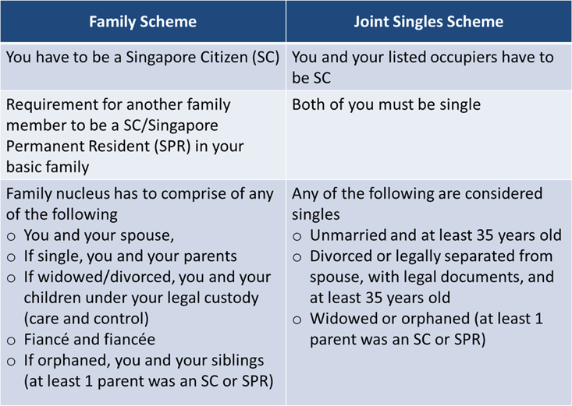

*Table xx: Rental Payable Per Month under the Public Rental Scheme*

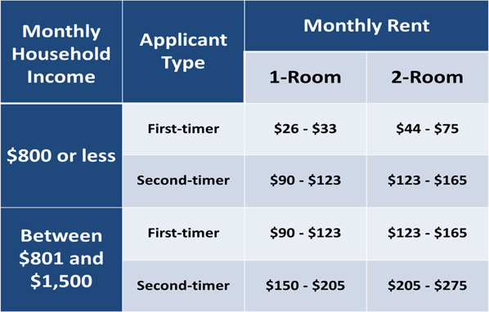

*Table xy: Median Rents by Town for 1- and 2-Room Flats for 3Q2017, (-) indicates no transaction in the quarter, * indicates less than 20 transactions in the town in the quarter (Source: HDB Website)*

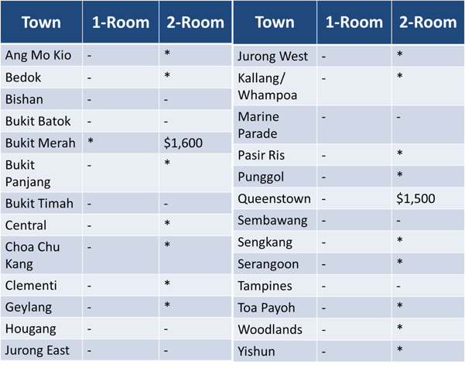

## Appendix C

*Figure 1.0 Ranking of 2017 Melbourne Mercer Global Pension Index in Asia*

*Source: MERCER STRAITS TIME GRAPHICS*

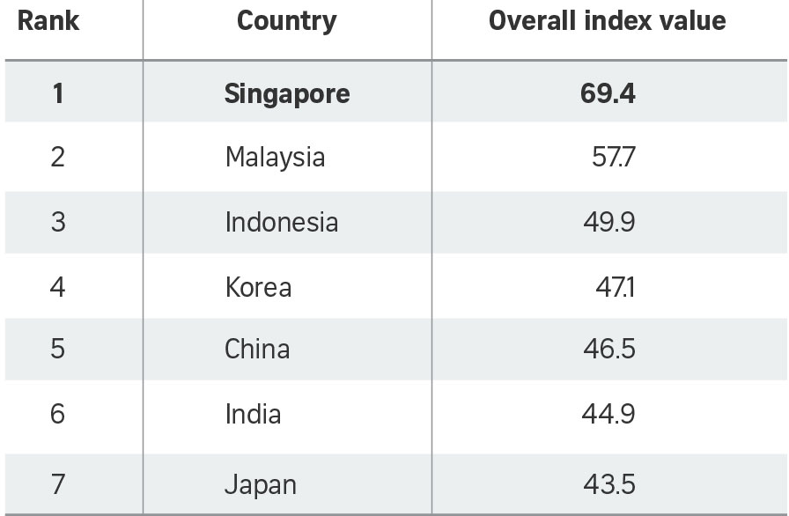

*Figure 2.0 Net amount withdrawn (Source: CPF Statistics)*

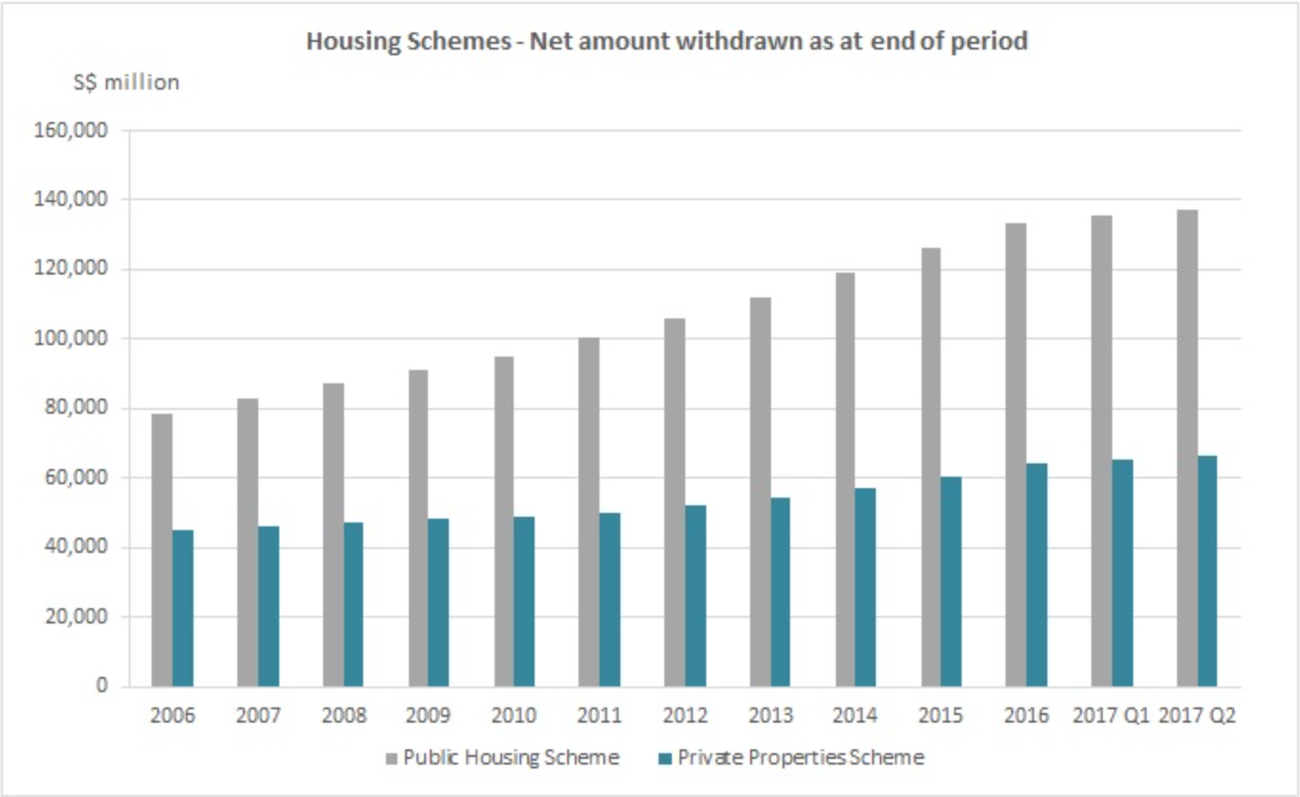

# Individual Contribution

Discussion & Editing: Everyone

Framework (writing: Harvey & Jiaqi)

1.1.1 Housing Options in Singapore (Yingchao)

1.1.2 Housing Options in Hong Kong (Harvey)

1.2 Housing Ladder (Harvey)

1.3.1 Housing difficulties and solution in Singapore (Jiaqi)

1.4 Housing difficulties and solution in Hong Kong (Yibei & Yingchao)

2. Millennial Generation’s Choice

2.1 Pension problem (Yingchao)

2.2 Rent instead of Buy (Yibei)

2.3 Migrate to homogenous coastal cities along the Strait of Malacca (Jiaqi)

Conclusion (Yibei)

Bibliography

Appendix

Appendix A

Appendix B

Appendix C

We enjoyed our time and would like to acknowledge Prof Tu for opportunity for us to collaborate together.